CC 207B Unit 5 Assignment
Name:Joseph Angelo O. Japitana Date: 10/13/2026
Year and Section: BSIT 3-B
Note: Upload your Flutter project to your assigned folder here -> https://github.com/WVSU-BSIT-Batch-2028/CC-207B_26-27_Activities. Read the instructions on submitting, including the file name/folder conventions in the GitHub repository.

I. CICT Org Fair App Development. The CICT is holding an Org Fair. Students browse the student organizations on their phone, open one to read about it, and sign up with a short form. Most of this app is already written for you. Your job is to finish 14 small pieces, explain how the rest works, and run experiments that show what each Flutter idea from 5.1 and 5.2 really does. You will write about 40 lines of code. (35 points)
Get the initial Flutter project source code from: https://github.com/WVSU-BSIT-Batch-2028/CC-207B_26-27_Samples/tree/main/Unit%205/assignment_org_fair

Here is the table specifying the code changes you need to perform:
File | What it does | What you do
lib/main.dart | Starts the app and sets the theme | Read (E1)
lib/data/orgs.dart | The Org class and a pretend web service, OrgRepository, that waits about 2 seconds and returns orgs, nothing, or an error | Read only. Do not change
lib/models/registration.dart | The Committee enum and the Registration class the form returns | Read
lib/widgets/state_message.dart | One layout for the loading, error, empty and no-results messages | Read
lib/widgets/org_card.dart | One org in the list | Read (E6)
lib/widgets/org_banner.dart | The banner photo, with loading and error handling | Read (E8)
lib/screens/org_list_screen.dart | Loads the orgs, search, list or grid, swipe and long-press | TODO 1 to 7; E2 to E5, E7
lib/screens/org_detail_screen.dart | One org with its banner and a Join button | TODO 8; E9
lib/screens/join_form_screen.dart | The sign-up form with 8 kinds of input | TODO 9 to 14; E10, E11
test/org_fair_test.dart | 7 automatic tests. Each one names the TODOs it checks | Run to check your work
Note: Run the command “flutter test” at any time. All tests should pass before submitting the assignment.

Each TODO is a comment in the code with a placeholder line under it. Replace the placeholder with your code. Most need 1 to 6 lines. In org_list_screen.dart the loading state is already written; use it as a pattern for TODO 4 and 5.
# | File | What to do | Slide topic
1 | org_list_screen | Start loading the orgs once in initState() | StatefulWidget Lifecycle
2 | org_list_screen | _reload(): fetch again inside setState() | What Does setState() Do?
3 | org_list_screen | _toggleFavorite(): add or remove the id inside setState() | setState; 5.1 Set
4 | org_list_screen | Error state with a Try again button | The Four States of Content
5 | org_list_screen | Empty state with a Refresh button | The Four States of Content
6 | org_list_screen | Search box onChanged saves the text with setState() | Getting Values from Users
7 | org_list_screen | Wrap each card in a Dismissible | Dismissibles
8 | org_detail_screen | Join button: disabled when already a member | Affordance and Feedback
9 | join_form_screen | validate() then save() the form | Handling forms with validation
10 | join_form_screen | Send the registration back with Navigator.pop | Navigation widgets
11 | join_form_screen | Email validator with helpful messages | When Should Errors Appear?
12 | join_form_screen | Student ID: digits-only formatter and validator | Input Validations (formatters)
13 | join_form_screen | Slider, Switch and Checkbox onChanged with setState() | Inputs Follow One Loop
14 | join_form_screen | Submit stays disabled until the checkbox is ticked | Affordance and Feedback

Evidence (Provide screenshots of the application to show that it is working):
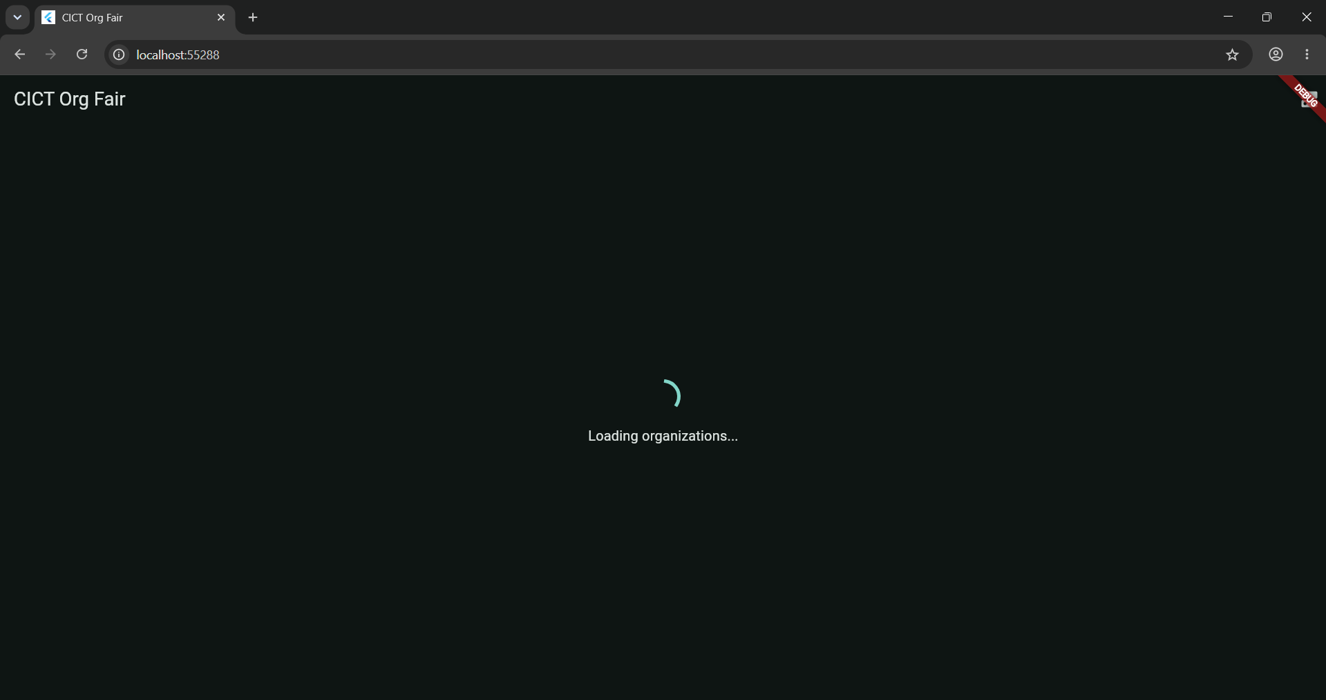
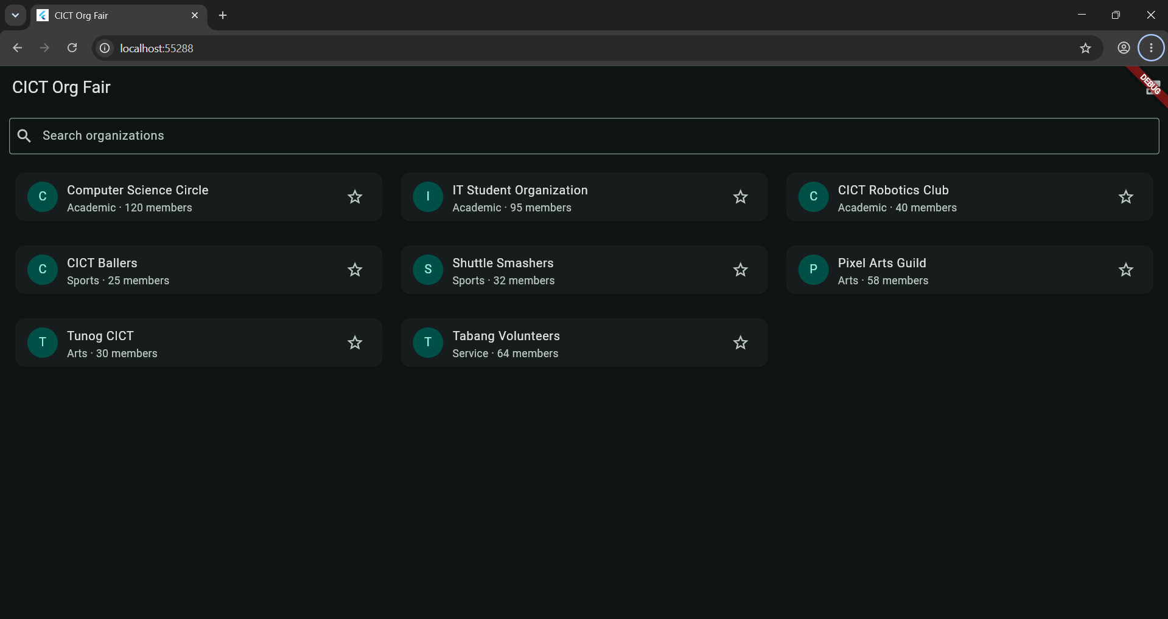
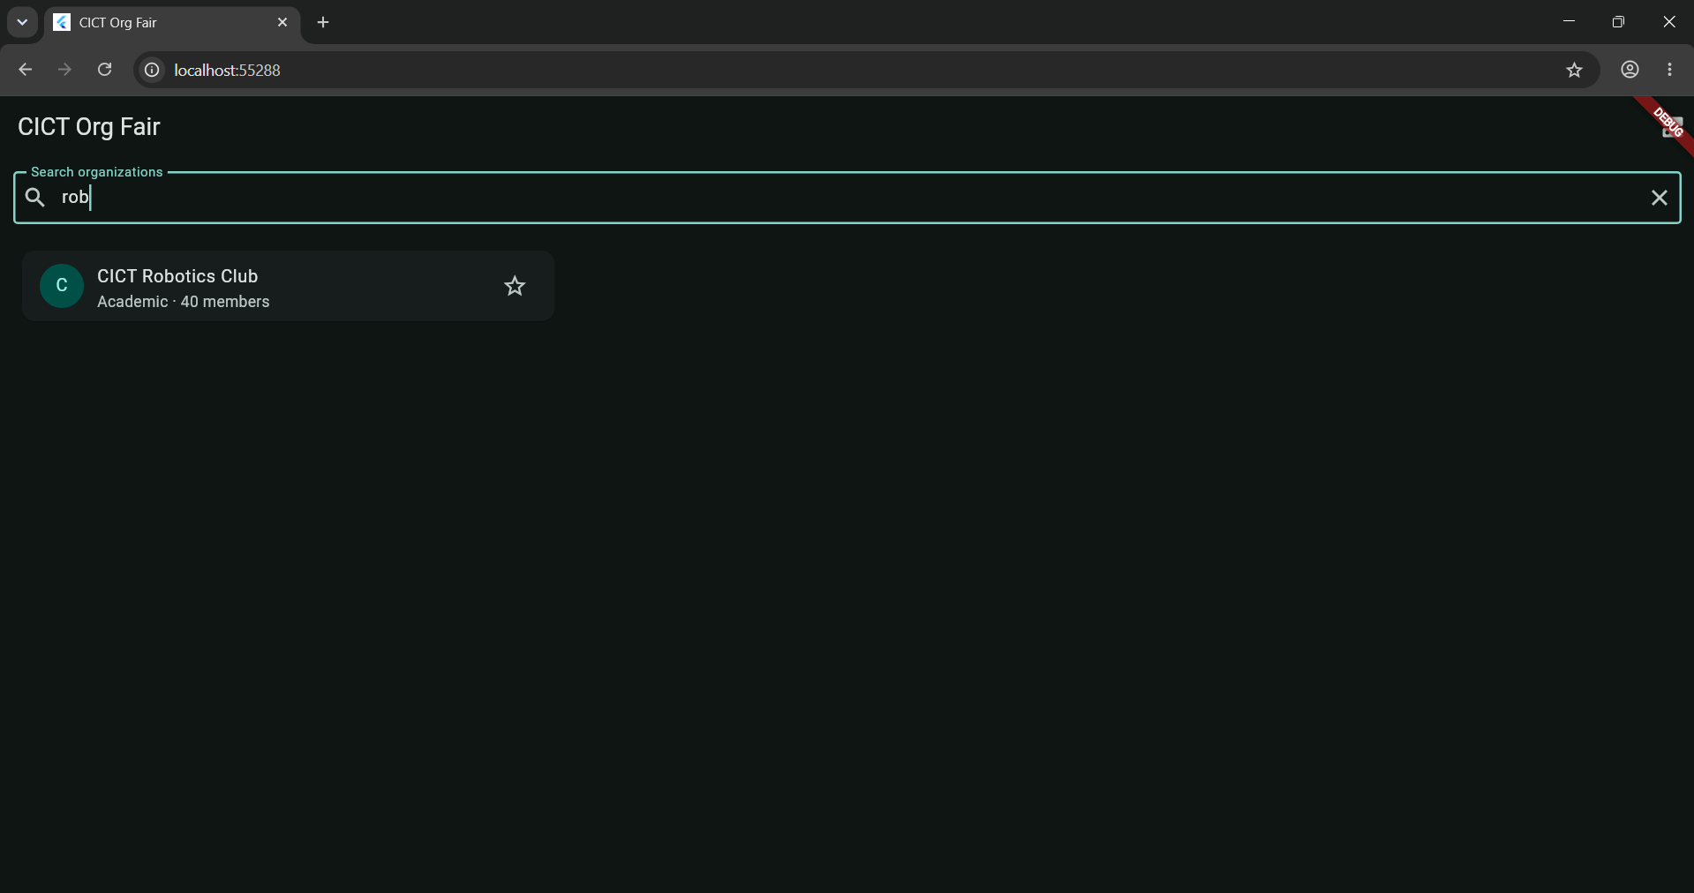
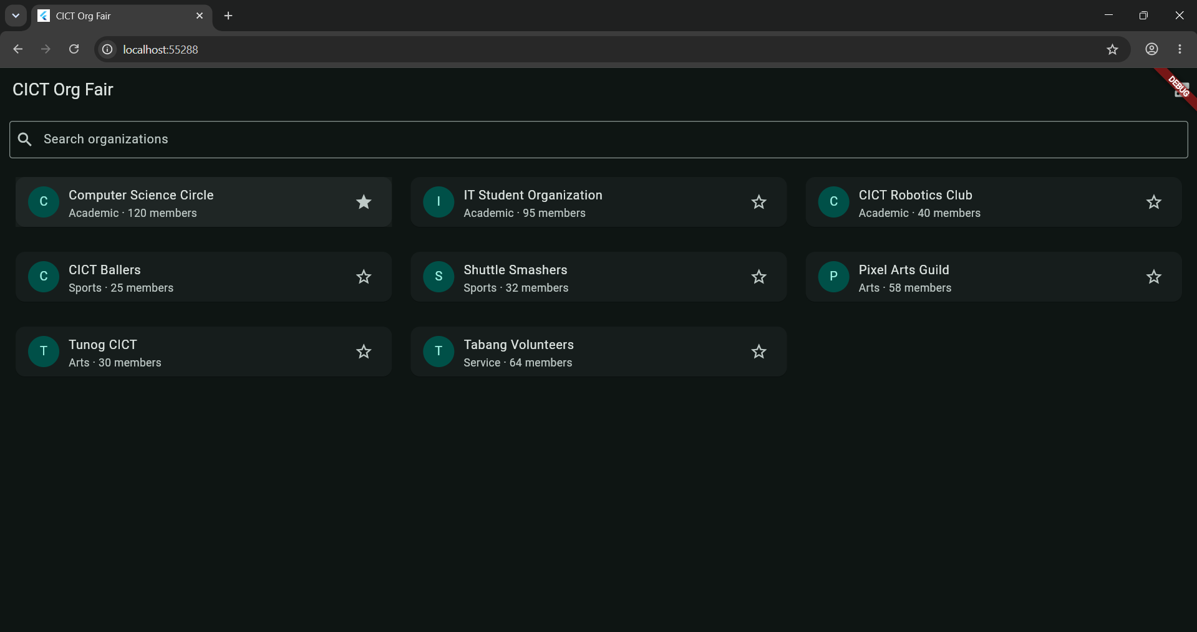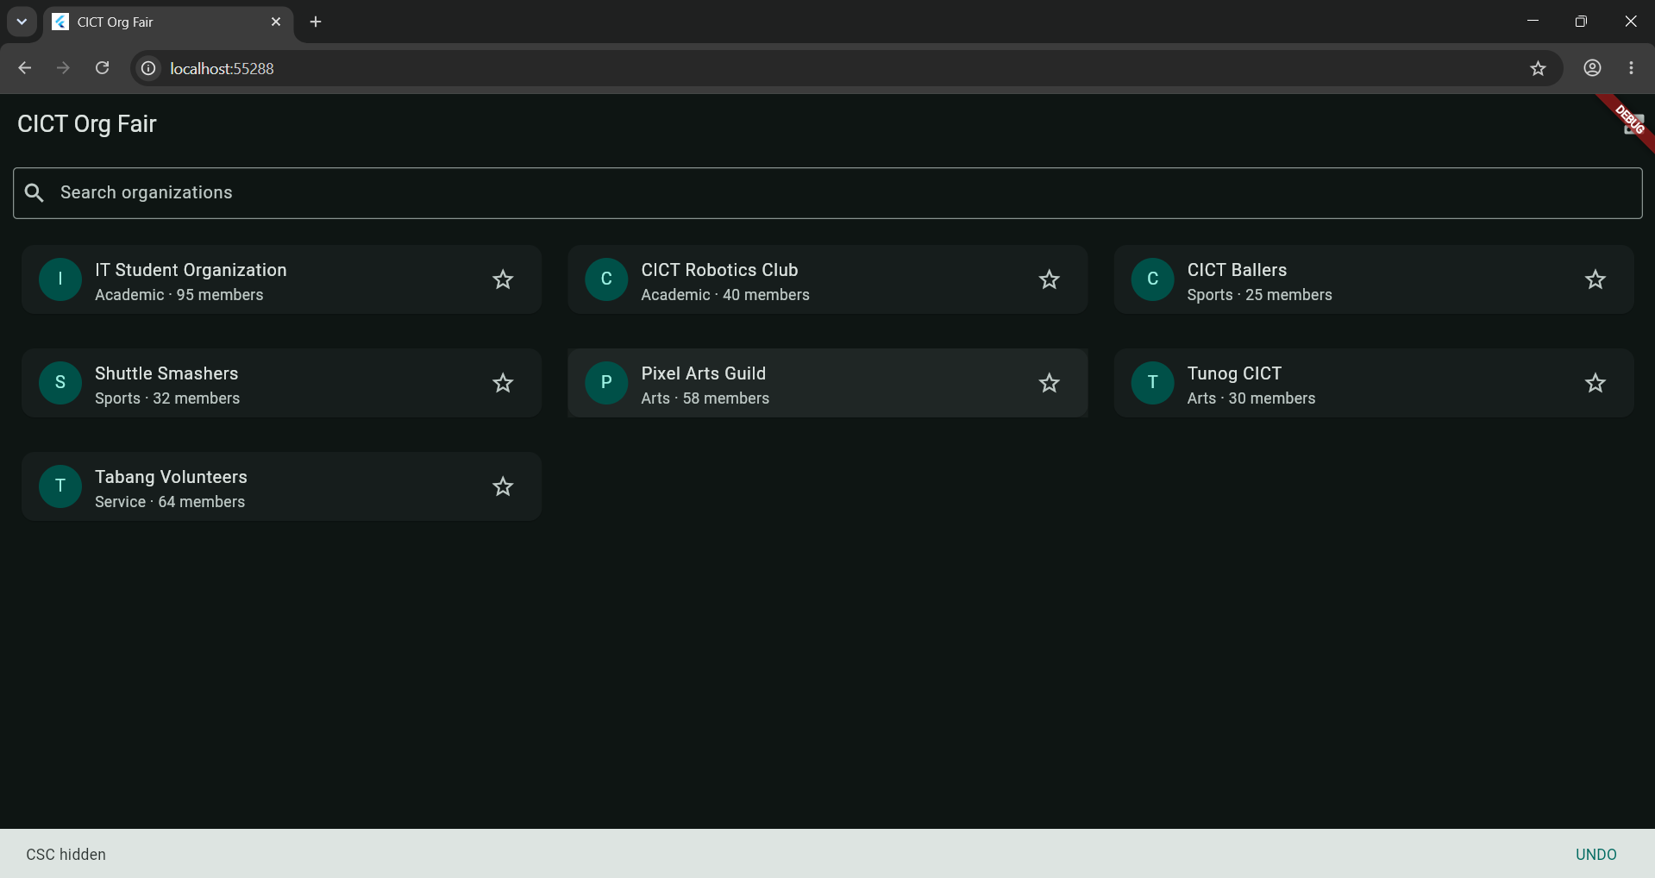
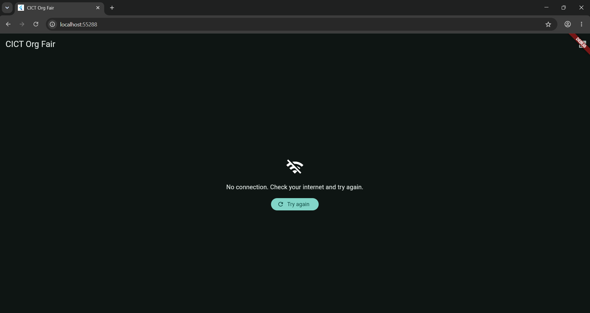
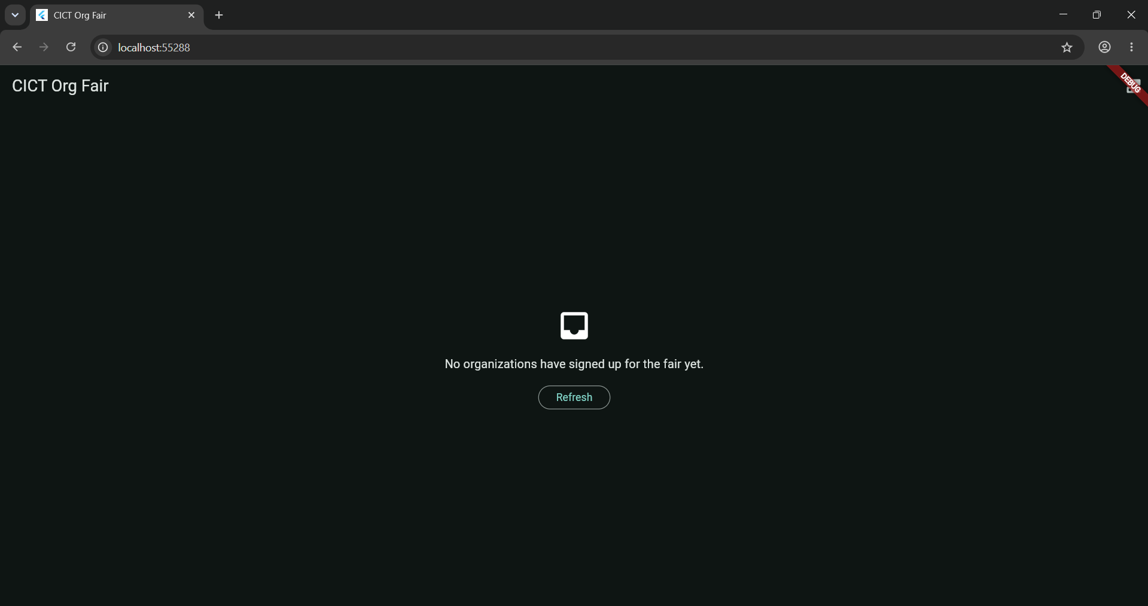

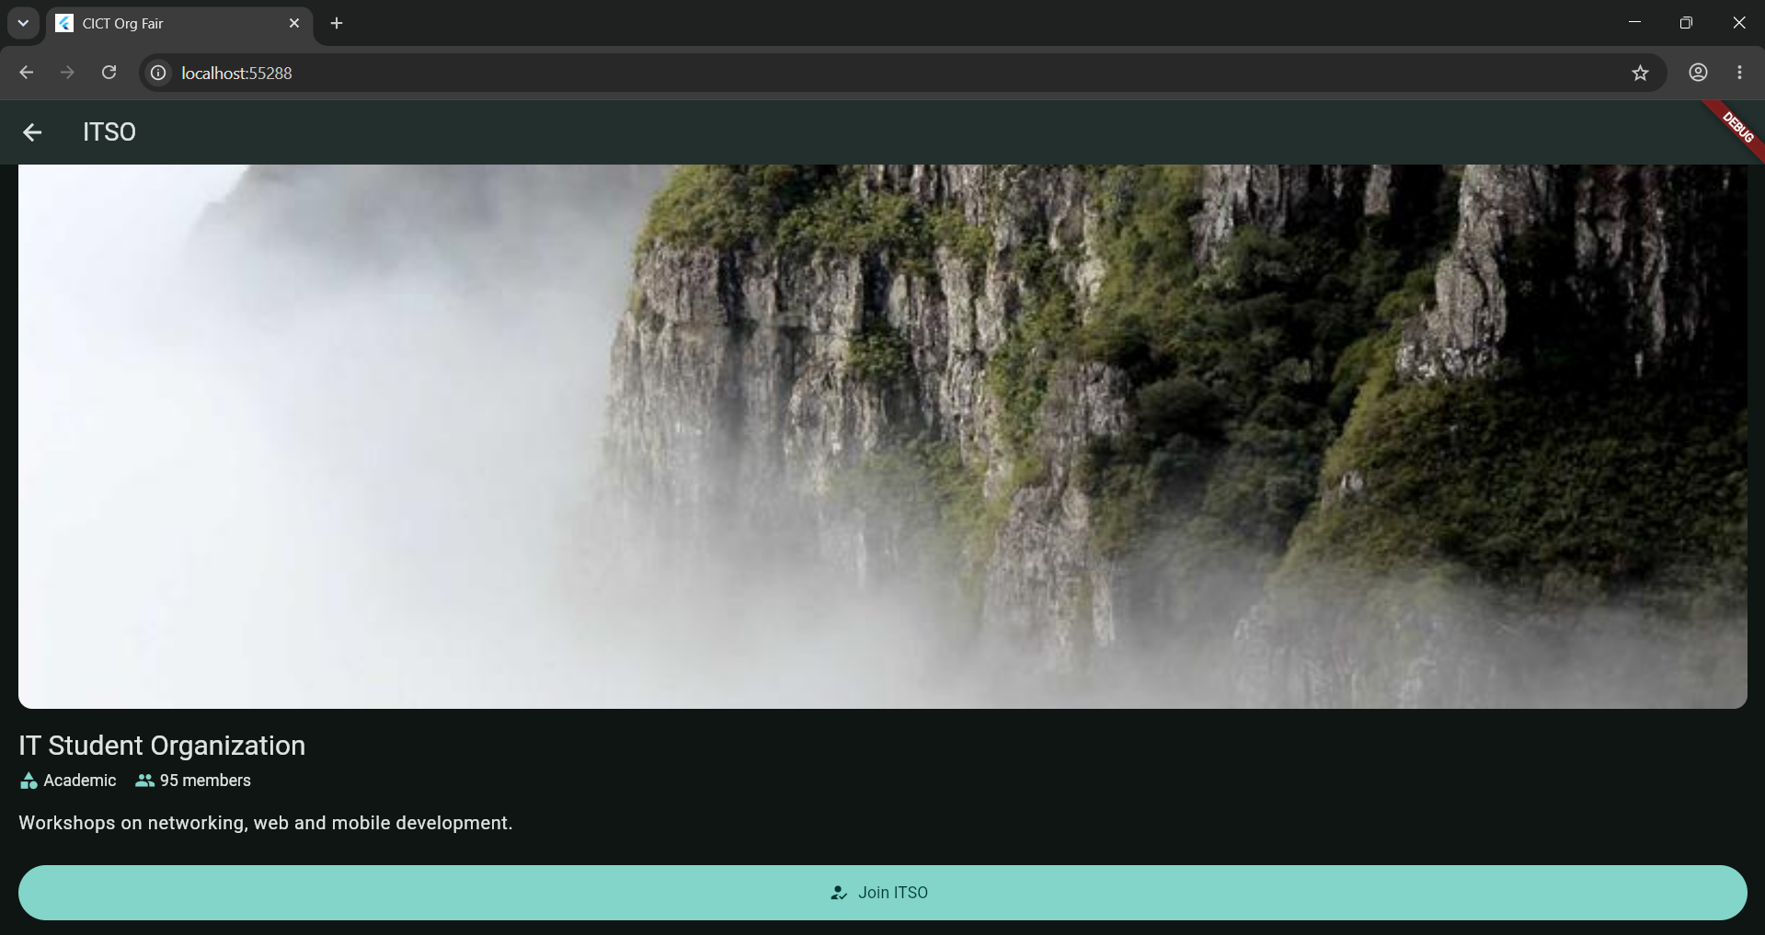
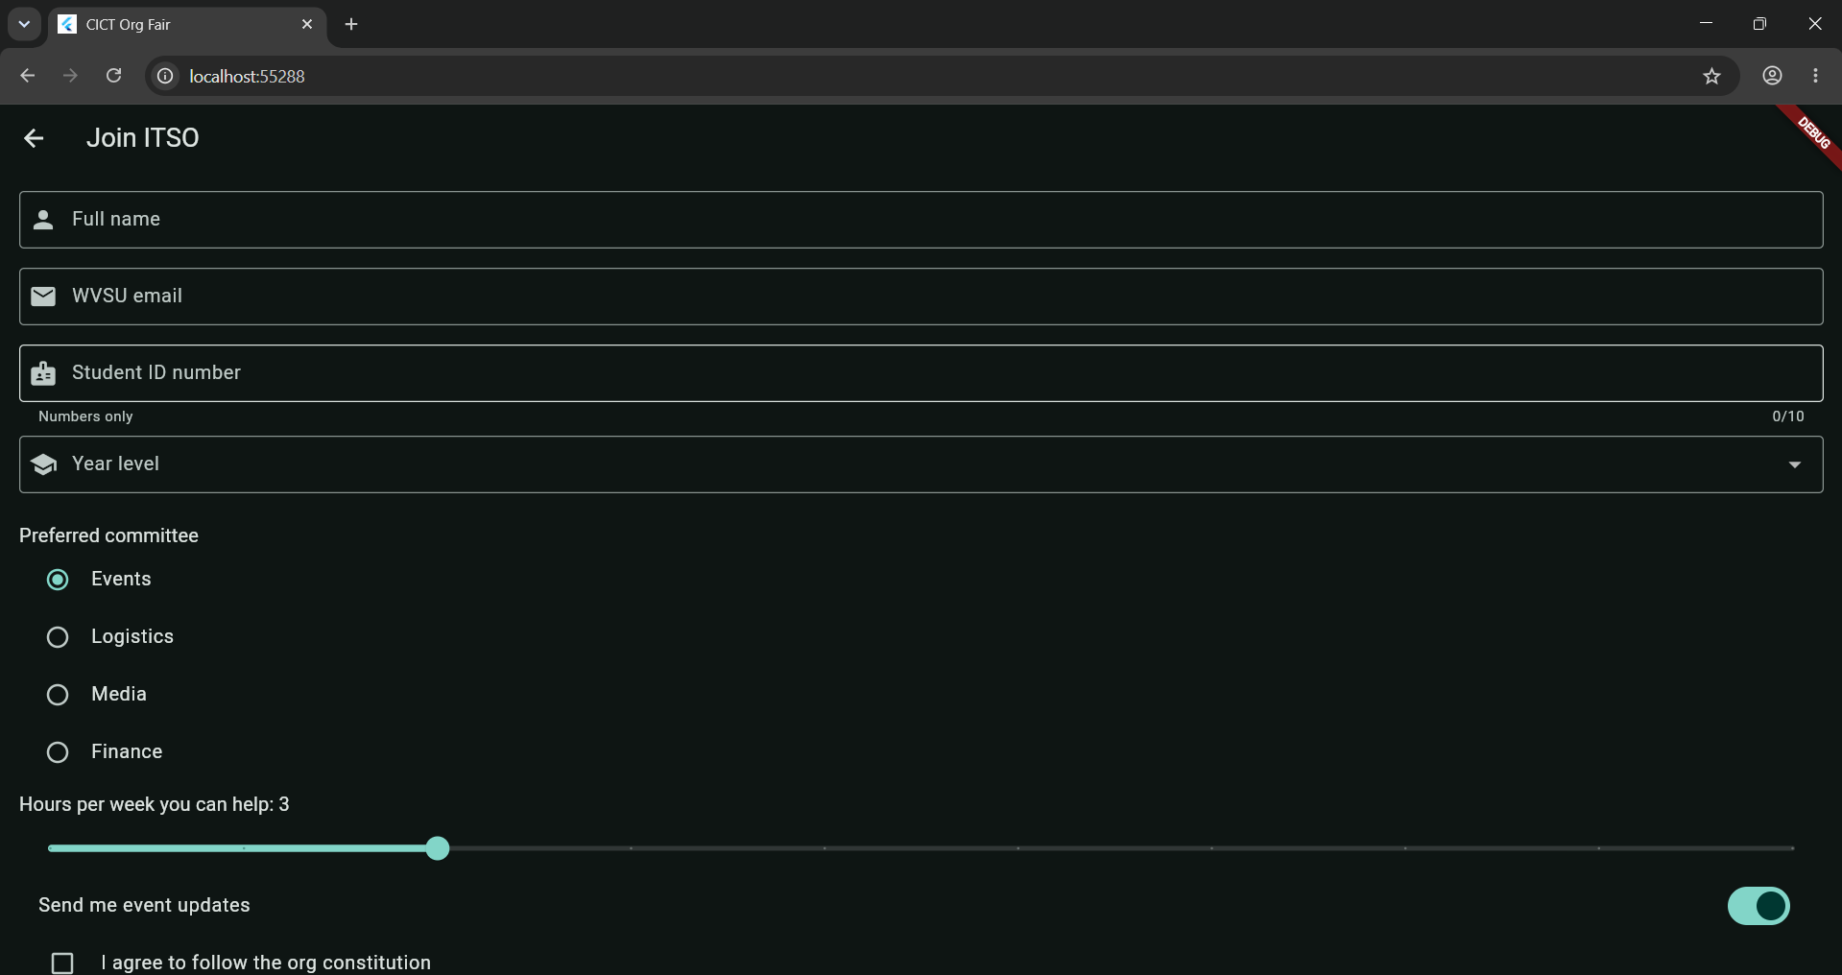
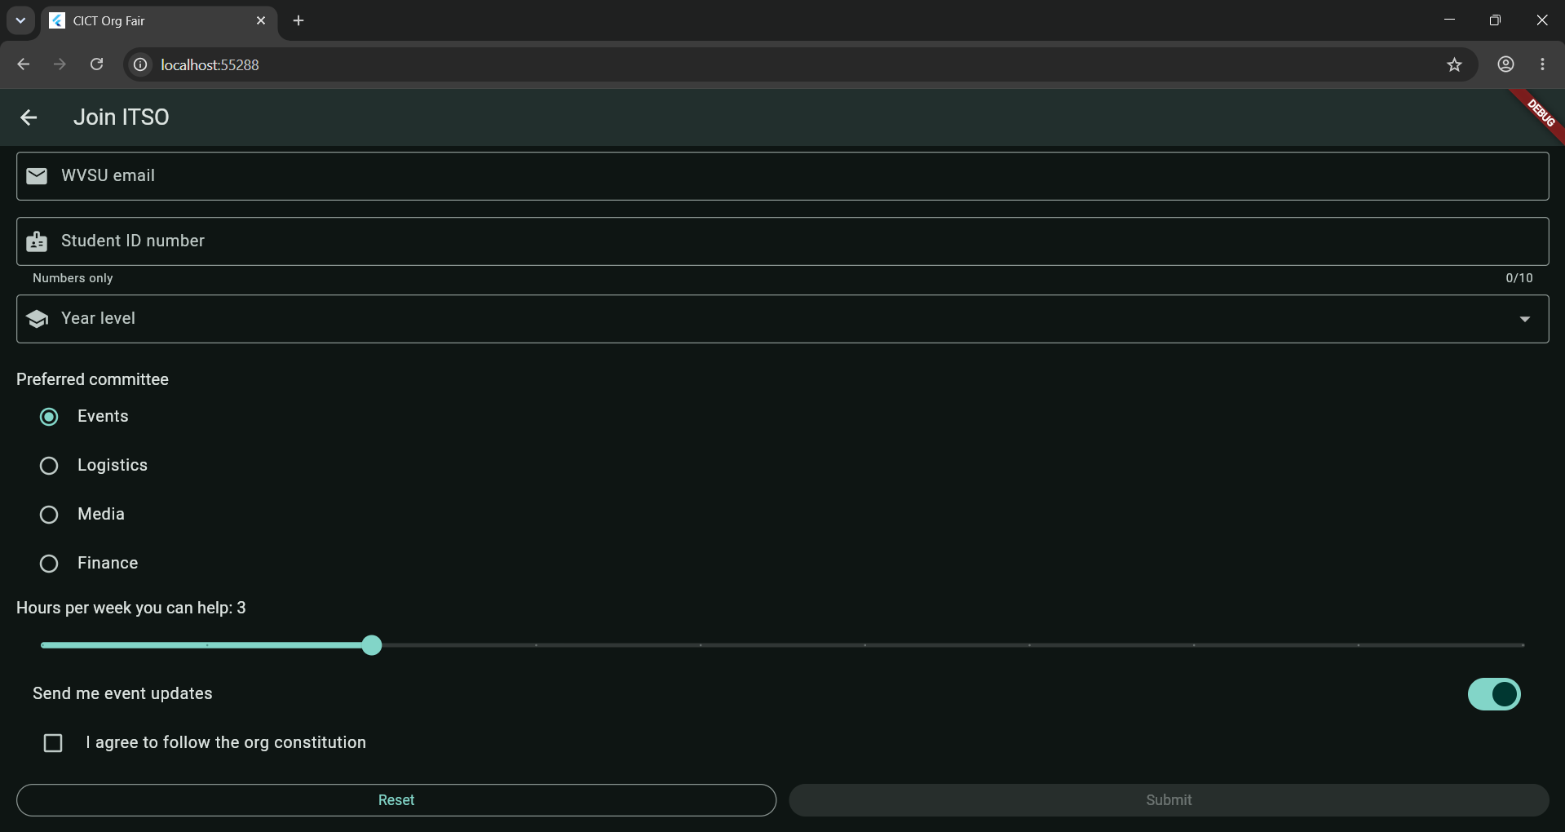
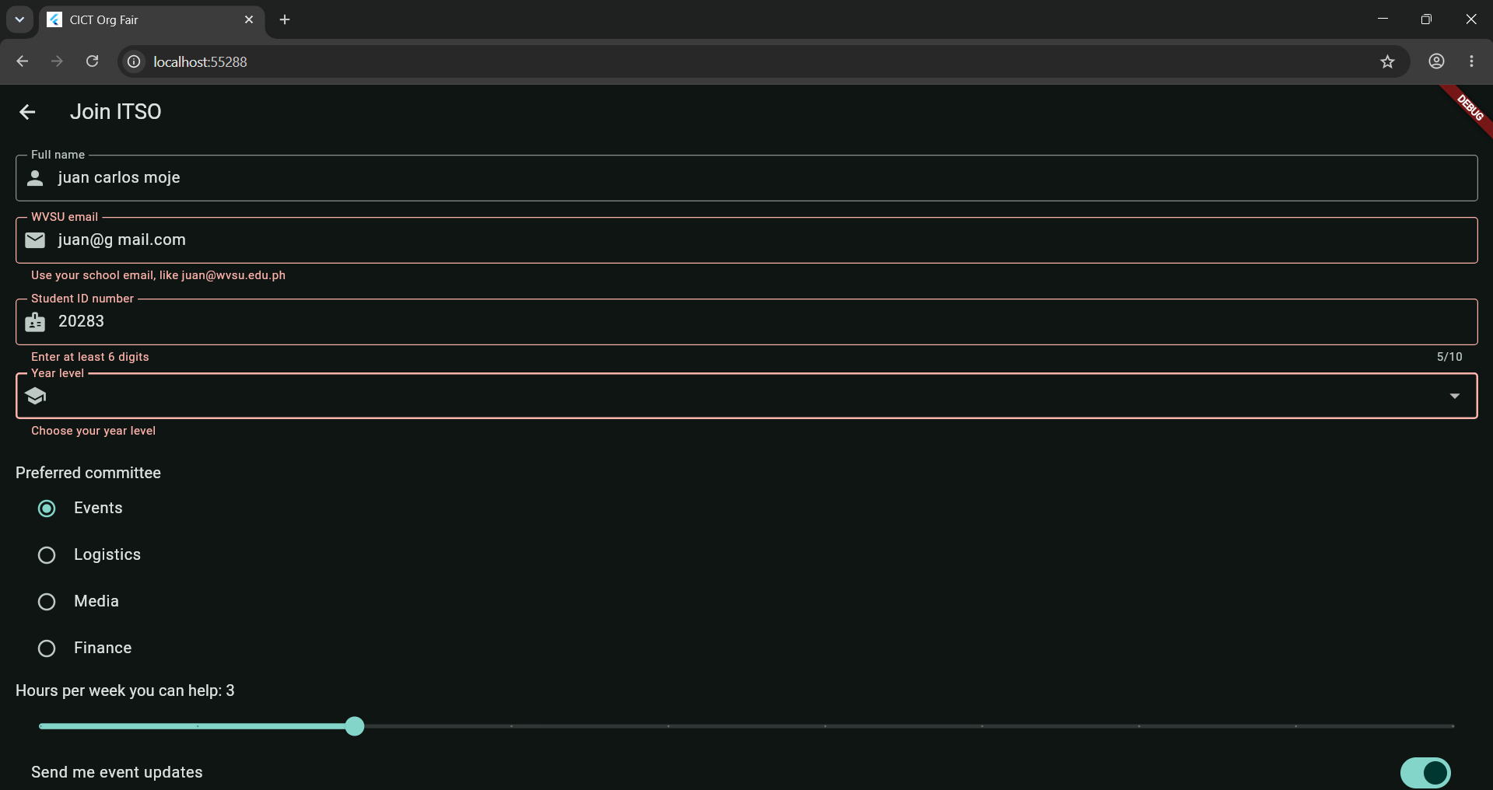
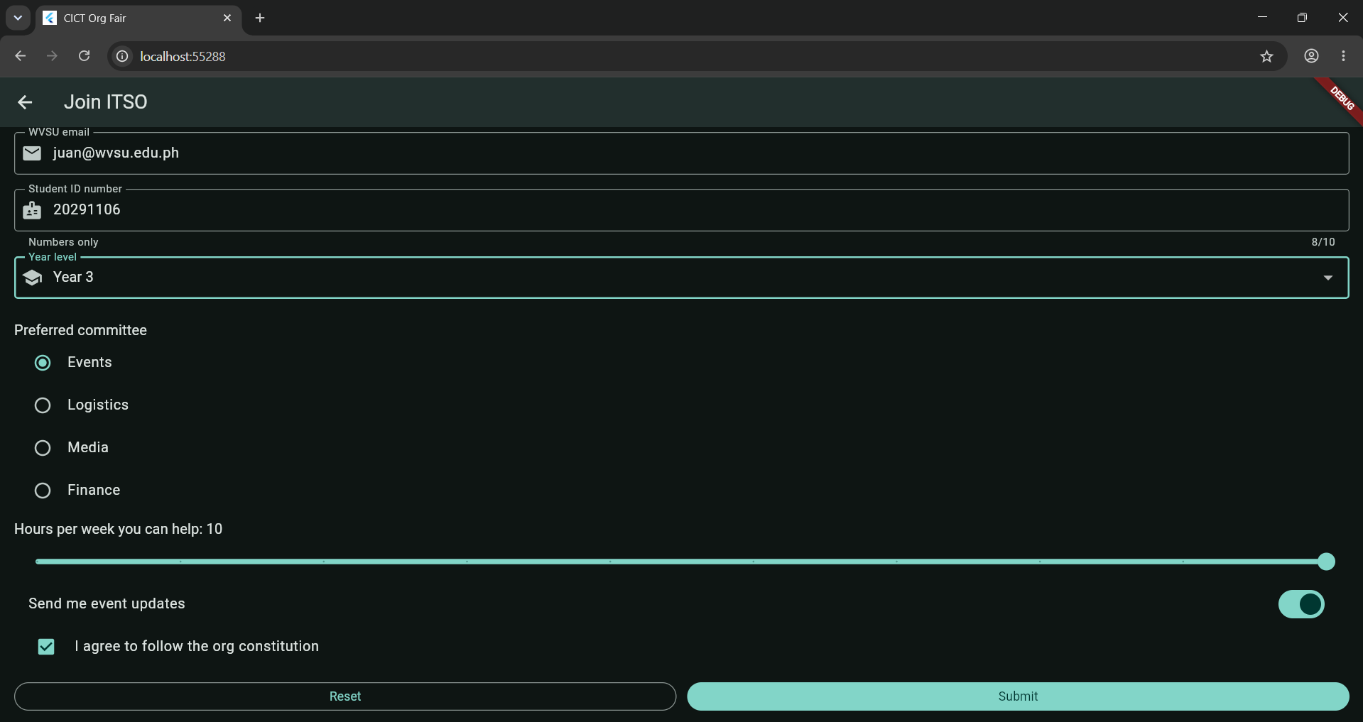
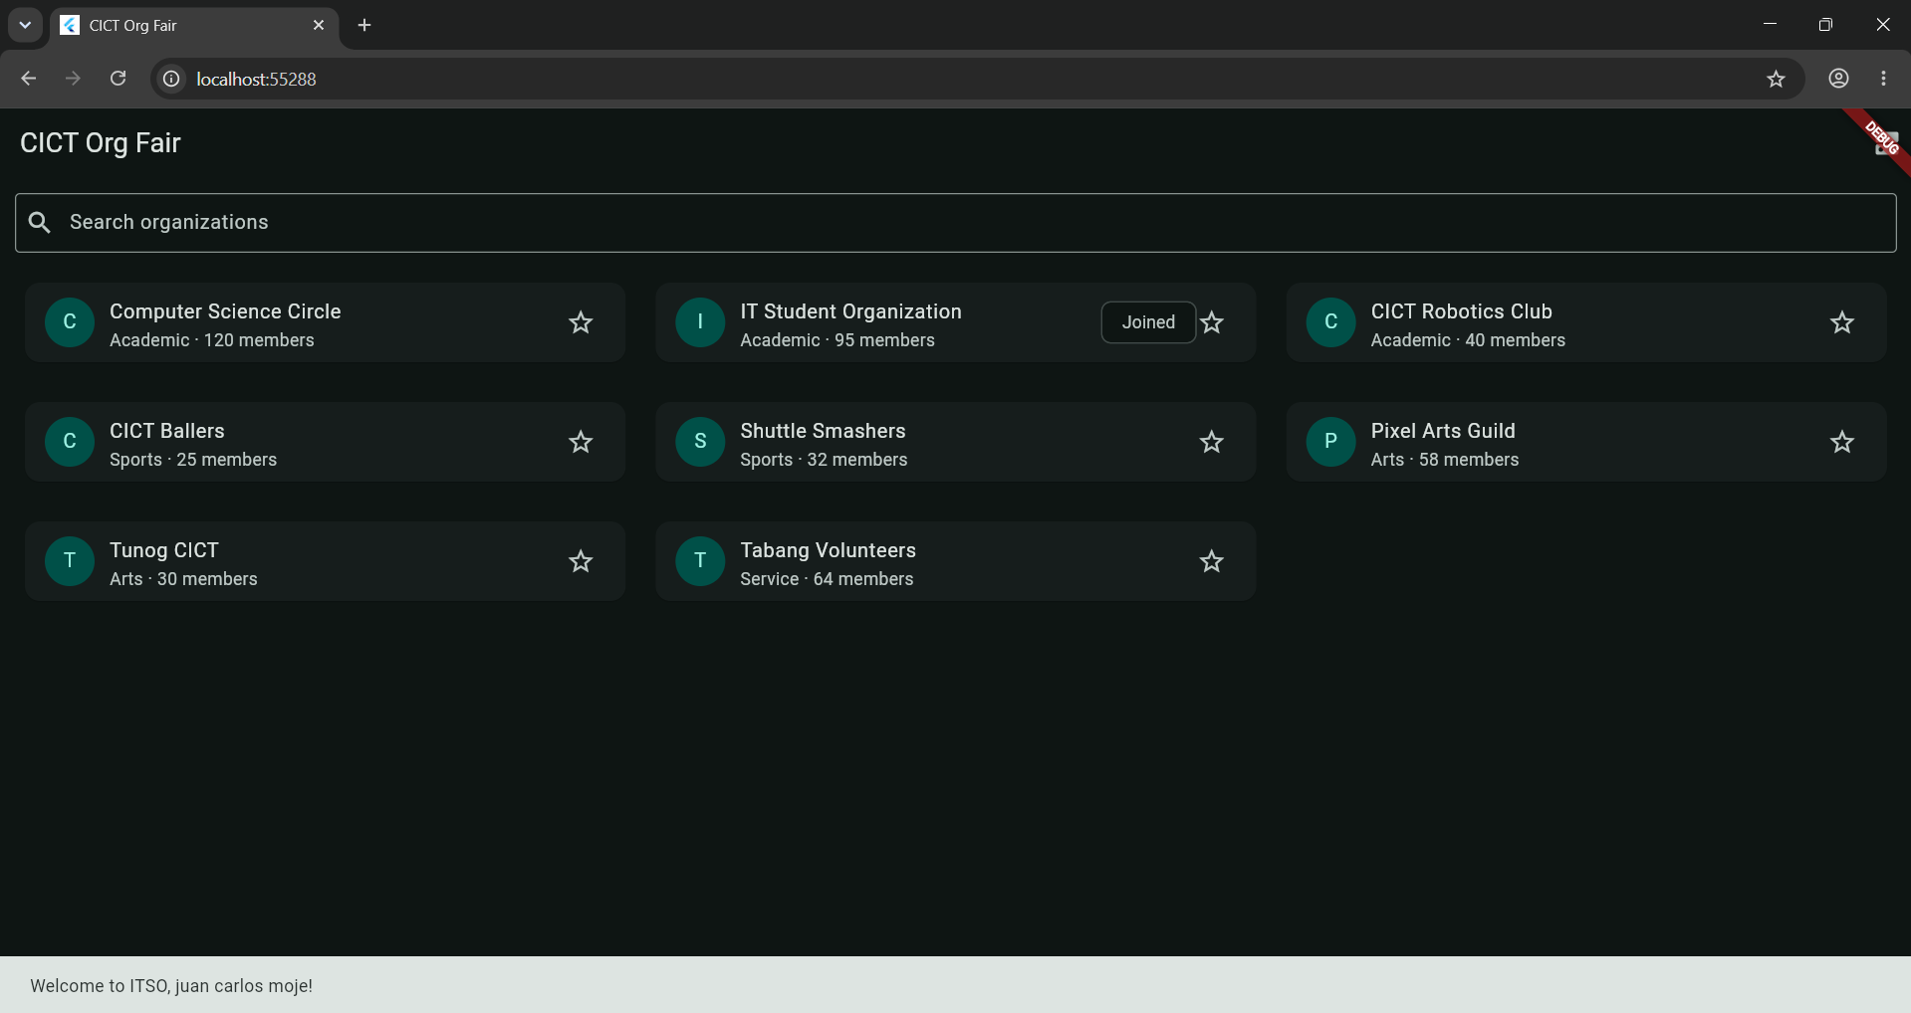
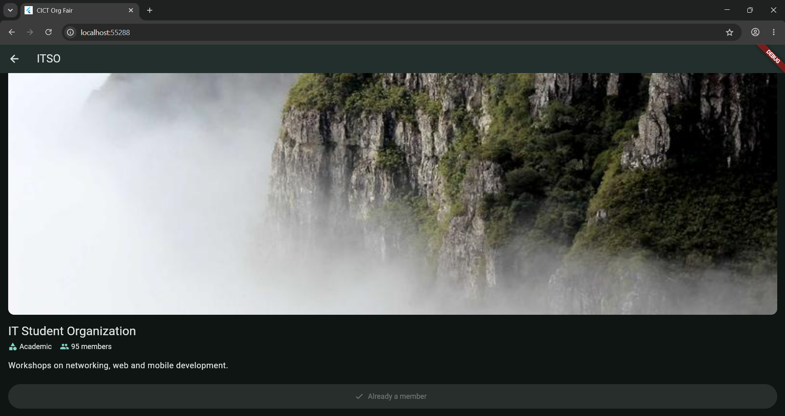
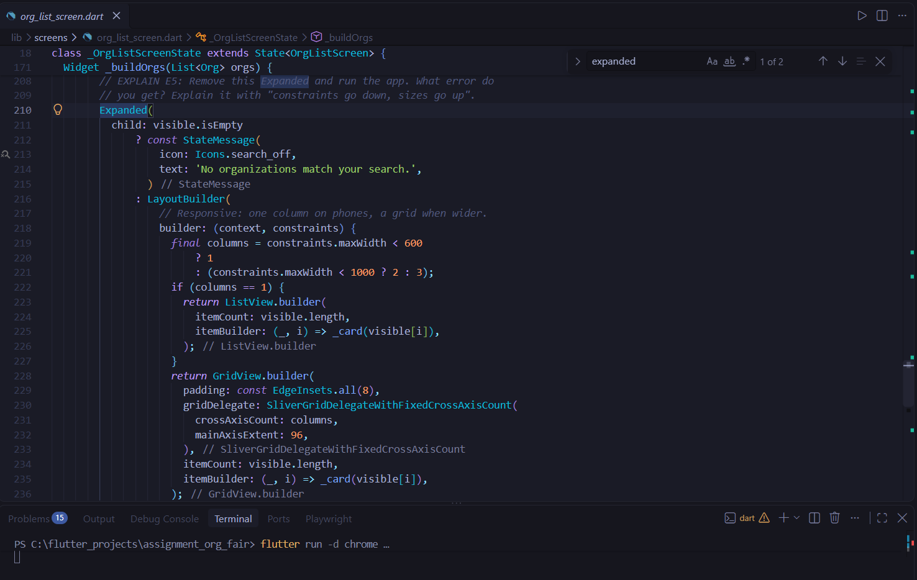
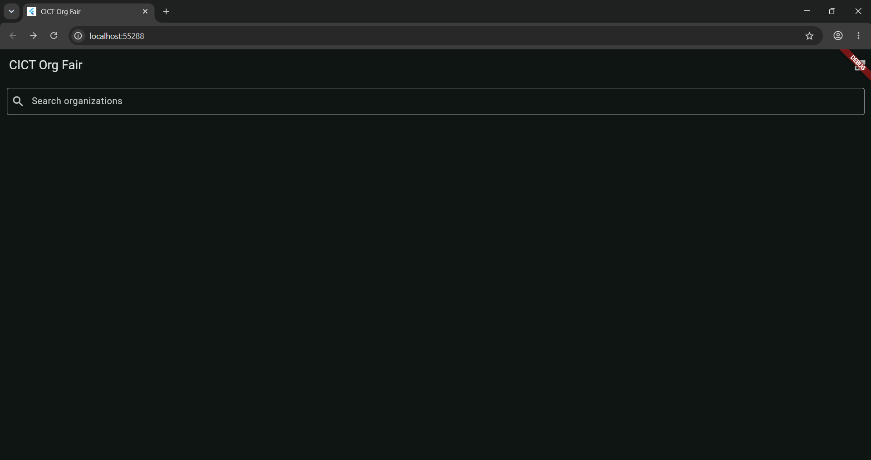
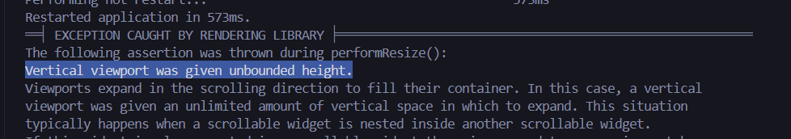
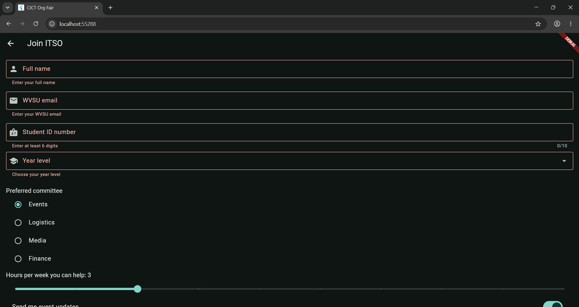
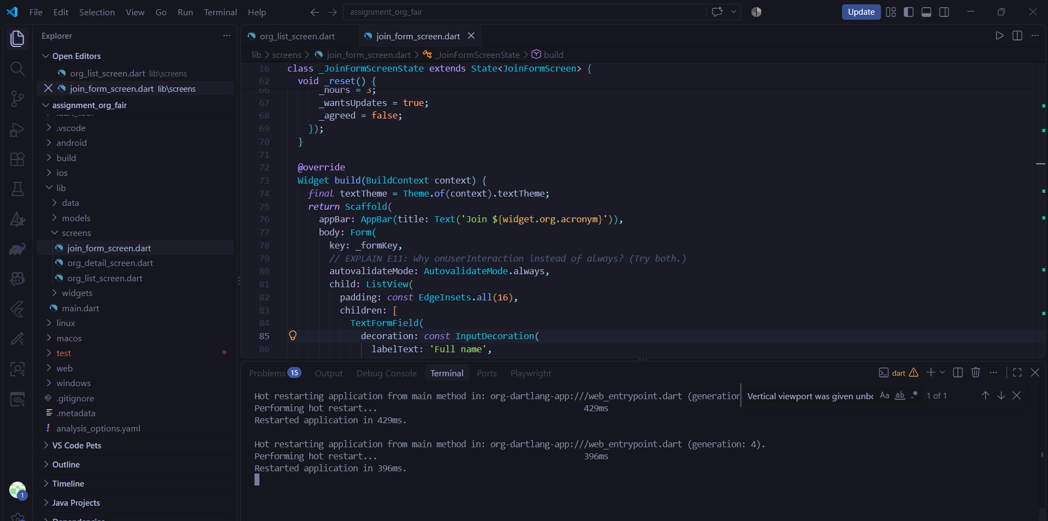
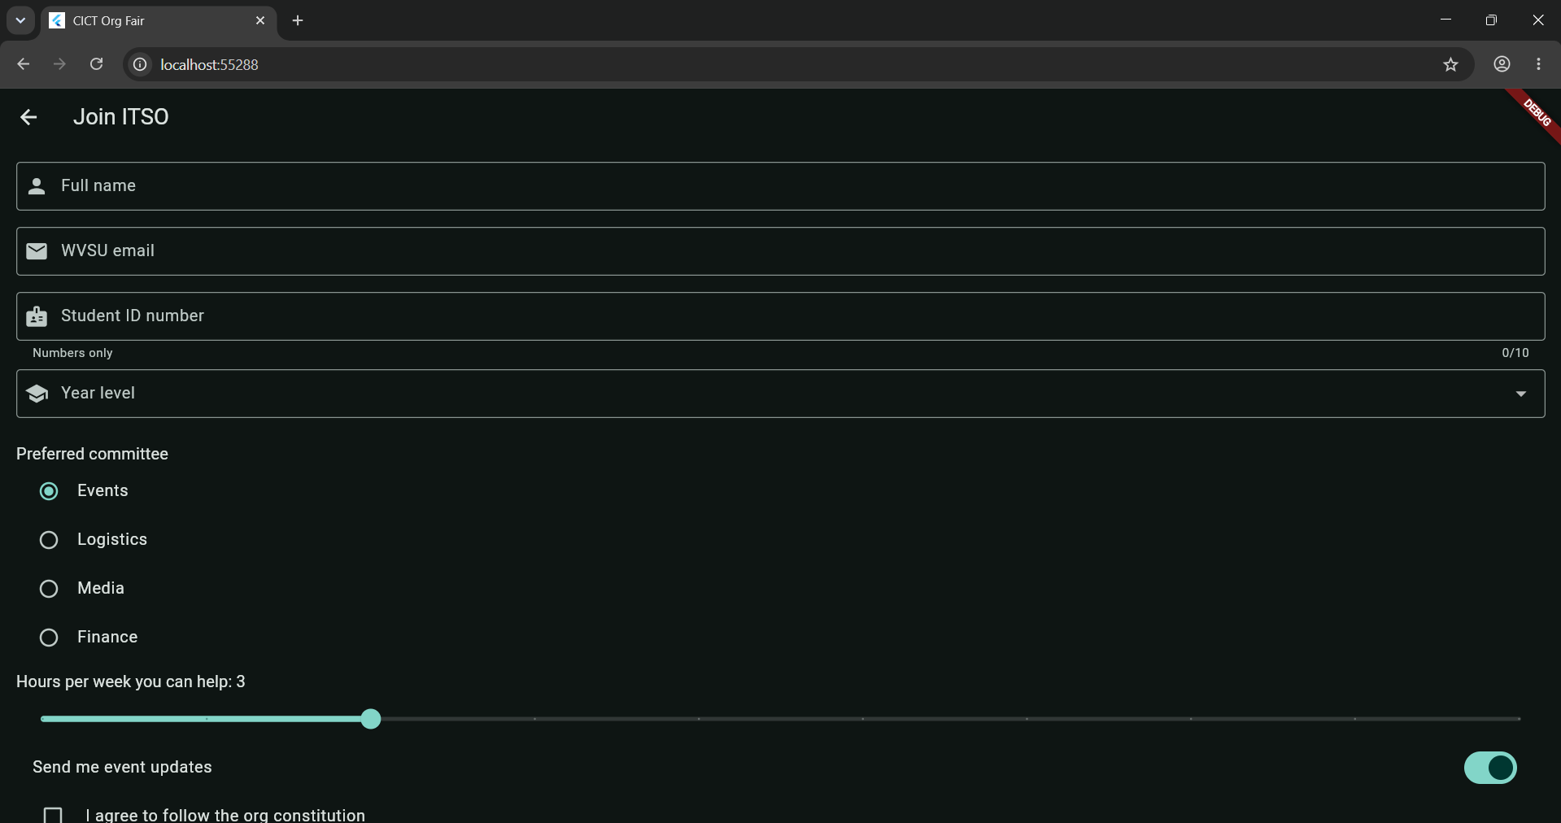
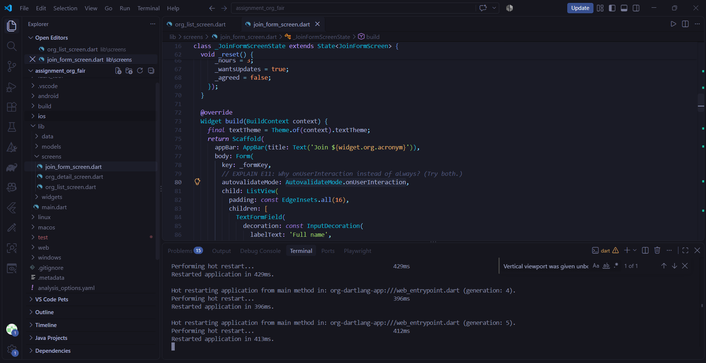
II. CICT Org Fair Code Analysis. The code has 11 comments that start with EXPLAIN E1 to EXPLAIN E11. Put your answers in the available column for each row. (2 points each)
# | Where | The question is about | Answer
E1 | main.dart | Why OrgFairApp is stateless but OrgListScreen is stateful? | OrgFairApp only holds the repository and theme, which never change, so it’s stateless. OrgListScreen has data that changes so it needs State and setState().
E2 | org_list_screen: dispose() | Why controllers must be disposed? | The controller is a ChangeNotifier with listeners that Flutter doesn’t free automatically. If not disposed, each time the screen is opened a controller stays in memory
E3 | org_list_screen: FutureBuilder | The order of states when the user presses Try again? | Error, Try again pressed, loading spinner about 2 seconds, error message again, because the server mode is still “error”.
E4 | org_list_screen: _buildOrgs | How the list updates while the user types? | onChanged calls setState() on every keystroke. This rebuilds the screen, and _buildOrgs() filters the list again using the new _query.
E5 | org_list_screen: Expanded | Constraints go down, sizes go up? | The Column gives the list unlimited height and the list tries to be as tall as its items, so it can’t pick a size and throws “Vertical viewport was given unbounded height.” Expanded gives it the remaining finite height.
E6 | org_card.dart | Where the favorite star's state lives? | The state lives in the parent’s _favoriteIds. A long-press calls onLongPress, the parent runs setState(), and it passes the new isFavorite value down to OrgCard.
E7 | org_list_screen: _openDetail | How data comes back from another screen? | push() completes with the value passed to Navigator.pop(). It is sent by Navigator.of(context).pop(registration) in _submit() of the form screen.
E8 | org_banner.dart | Null safety and the loading and error builders? | No URL: the if (url == null) line shows a placeholder with a groups icon. Loading: loadingBuilder shows a spinner. Failed: errorBuilder shows a broken-image icon. Copying bannerUrl to a local variable lets Dart treat it as non-null after the check.
E9 | org_detail_screen: _join | Why check context.mounted after await? | After an await, the user may have left the screen, so the context may no longer be valid. context.mounted checks the widget is still on screen before using it.
E10 | join_form_screen: _formKey | What a GlobalKey<FormState> gives you? | It gives access to the Form’s state from outside the widget. The three methods are validate() (runs validators), save() (runs onSaved) and reset() (clears the form).
E11 | join_form_screen: autovalidateMode | When errors should appear? | With always, errors show on an empty form before the user types anything. With onUserInteraction, errors show only after the user touches a field.

Determine what type of widgets and whether they are either stateless or stateful. (2 points each)
Feature | Widget(s) used | Stateless or Stateful? Why?
Org list or grid | ListView.builder / GridView.builder, OrgCard | Stateful. It owns data that changes
Favorite star | Icon inside OrgCard | Stateless. It only shows the isFavorite value passed in. The parent keeps the state.
Banner image | Image.network in OrgBanner | Stateless. It only displays the org’s data and has no state of its own.
Submit button | FilledButton in JoinFormScreen | Stateful screen. onPressed depends on _agreed, which changes through setState().

